**Accessing VMs for Docker at UIS**

1. Answer the exercise below with screenshots attached to your report

a. Access your VM using SSH shell

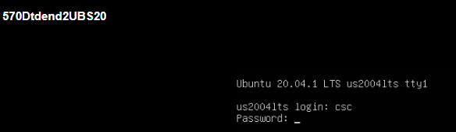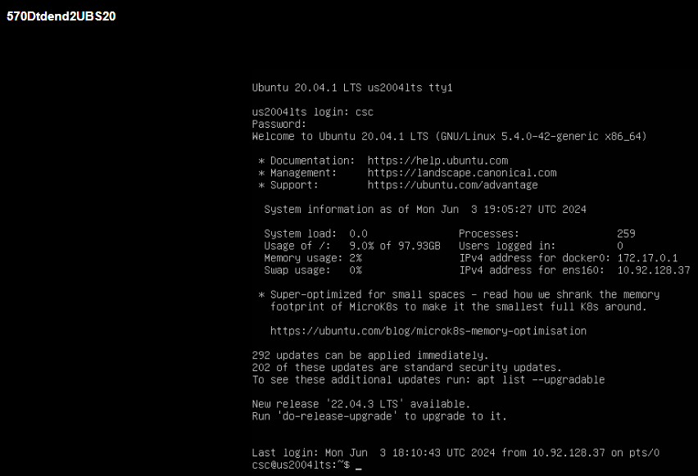

Using ssh : ssh csc@10.92.128.37

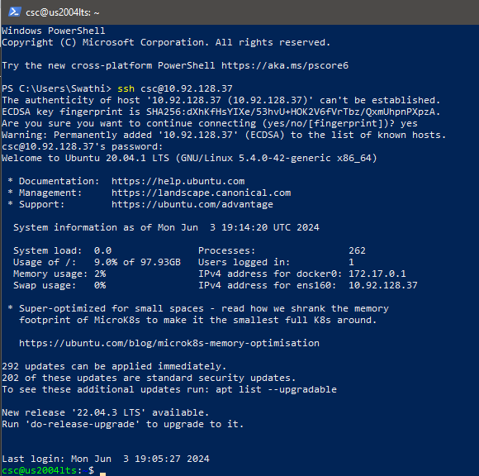

b. Create your account

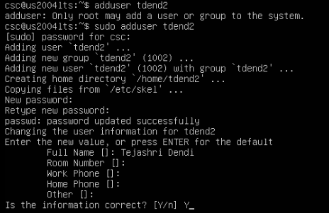

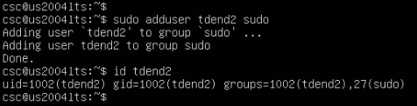

After adding the user tdend2 to sudo, exiting and relogged in :

**sudo tdend2@10.92.128.37**

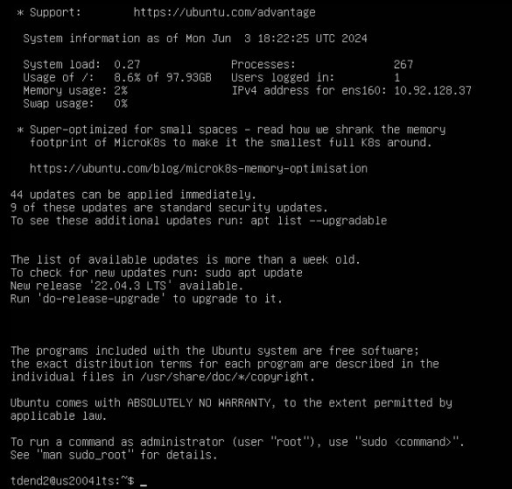

Using powershell: ssh tdend2@10.92.128.37

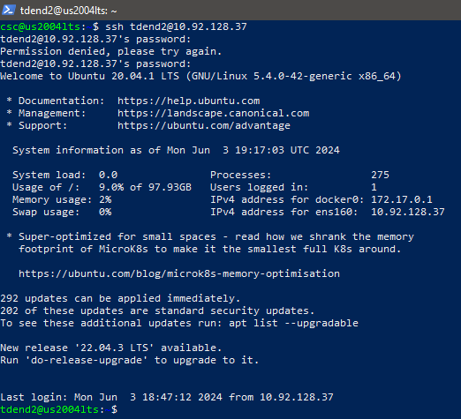

c. Install Docker on your VM and run hello-world

**Installation of Docker**

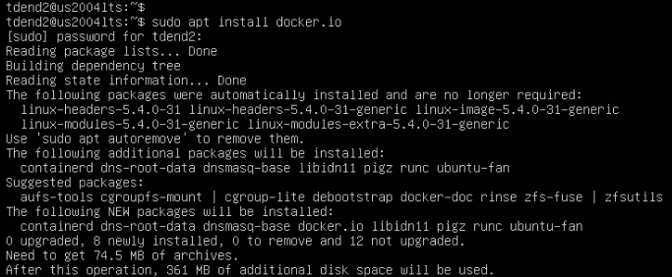

**Start docker and enable it to start after the system reboot:**



**Gave any user administrative privileges to docker & checked the docker version:**



*The docker version (The version up to date) : 24.0.5*

*Using windows powershell: docker –version*

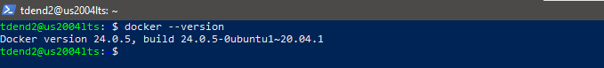

**Run the docker test using the hello-world container:**

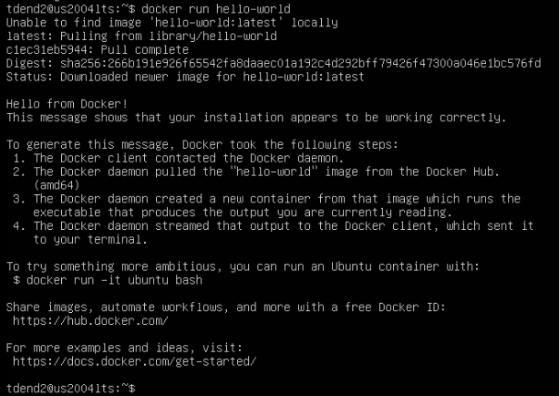

**Using windows power shell, ran hello-world:**

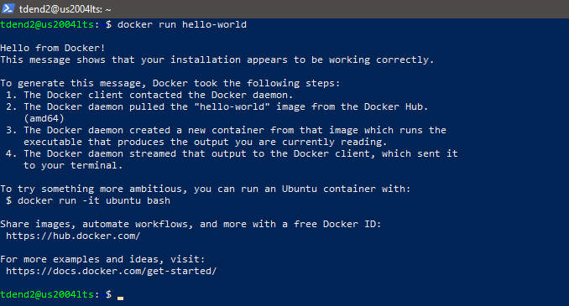

**===============================THE END============================**